Interrupts and the Timers
Introduction
This chapter will introduce you to the use of interrupts on the ARM® Cortex-M4® and the general purpose timer module (GPTM). The lab will use the timer to generate interrupts. We will write a timer interrupt service routine (ISR) that will blink the LED.
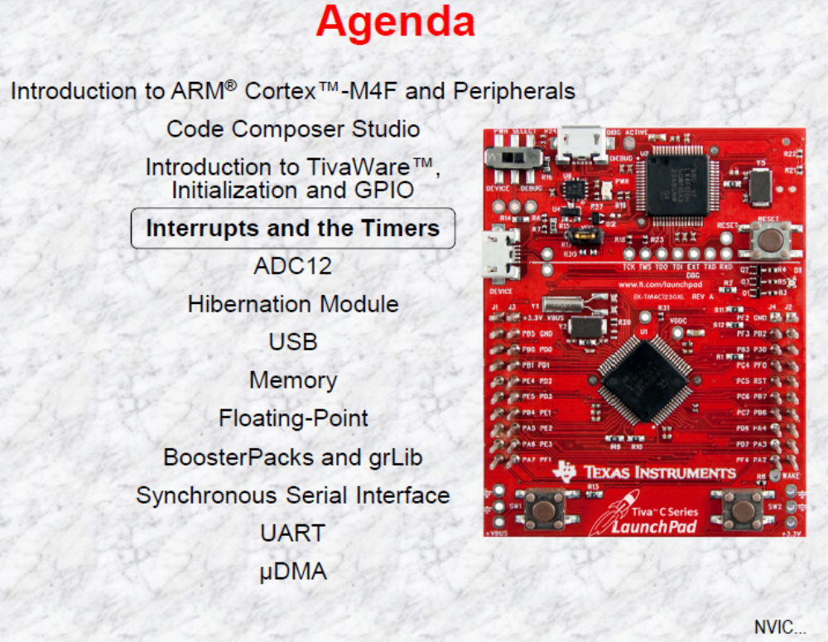
Cortex-M4 NVIC
Nested Vectored Interrupt Controller (NVIC)
◆ Handles exceptions and interrupts
◆ 8 programmable priority levels, priority grouping
◆ 7 exceptions and 65 Interrupts
◆ Automatic state saving and restoring
◆ Automatic reading of the vector table entry
◆ Pre-emptive/Nested Interrupts
◆ Tail-chaining
◆ Deterministic: always 12 cycles or 6 with tail-chaining
Cortex-M4® Interrupt Handling
Interrupt handling is automatic. No instruction overhead.
Entry
◆ Automatically pushes registers R0–R3, R12, LR, PSR, and PC onto the Stack  In parallel, ISR is pre-fetched on the instruction bus. ISR ready to start executing as soon as stack PUSH complete.
Exit
◆ Processor state is automatically restored from the stack in parallel, interrupted instruction is pre-fetched ready for execution upon completion of stack POP.
Cortex-M4® Exception Types
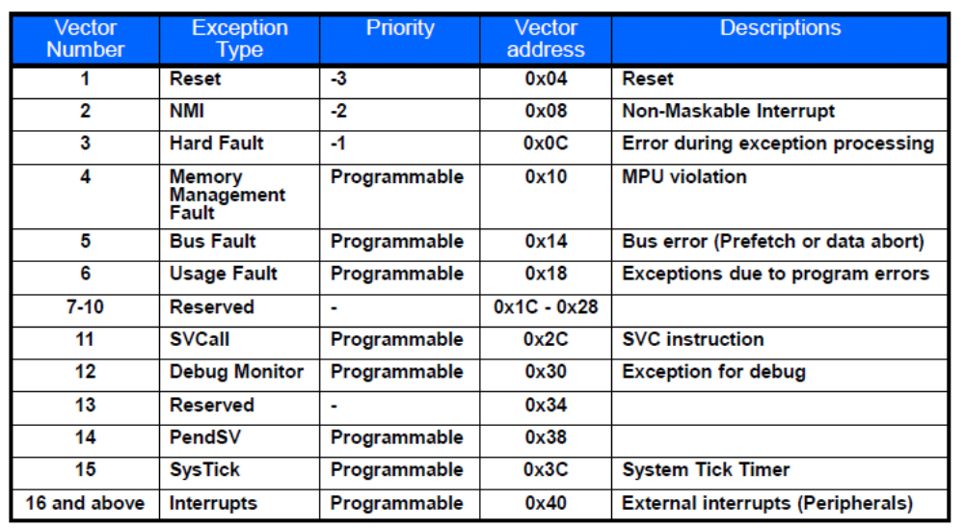
Cortex-M4® Vector Table
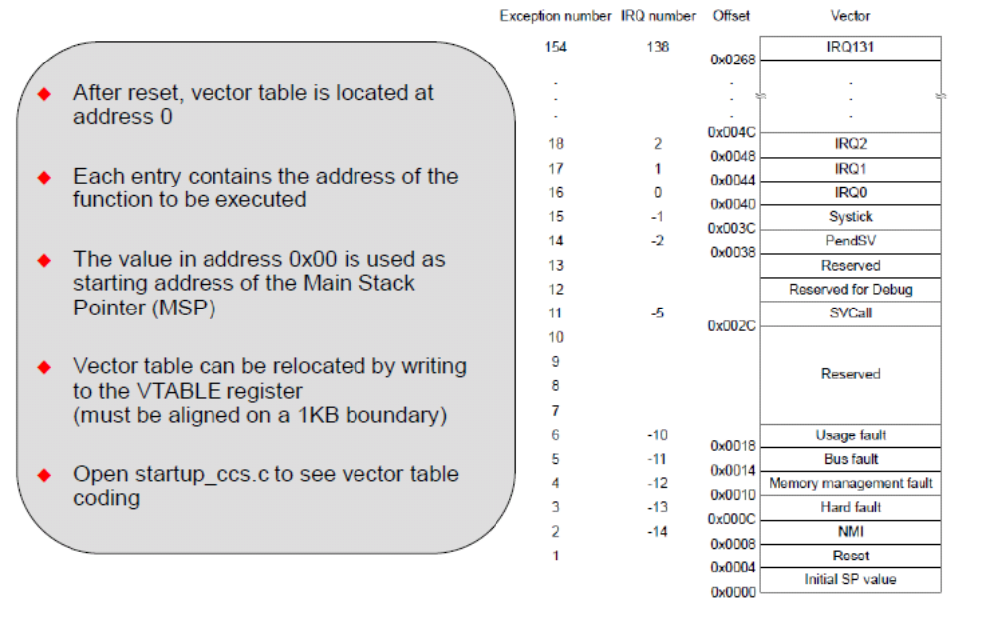
General Purpose Timer Module
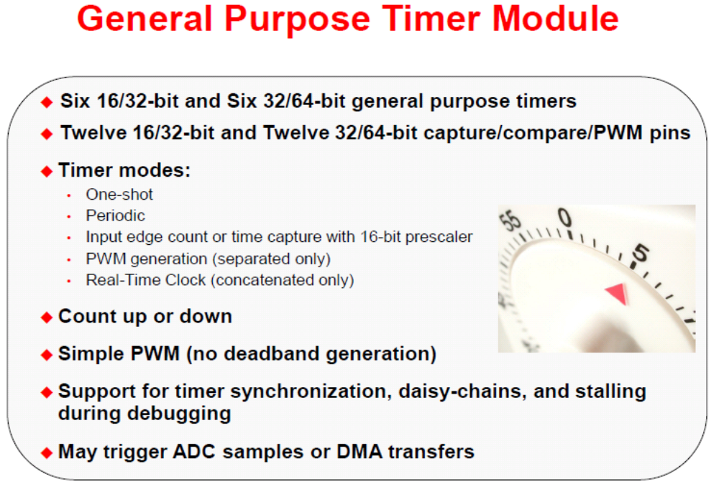
Cortex-M4 Interrupt Handing and Vectors
Interrupt handling is automatic. No instruction overhead.
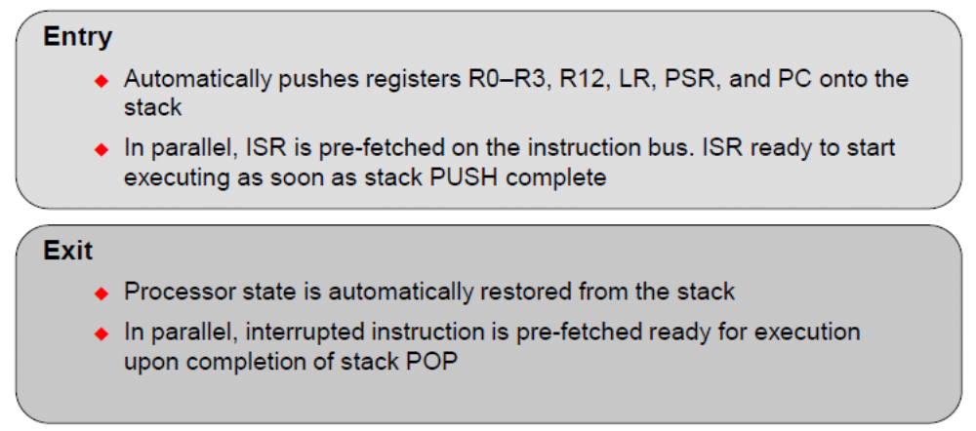

Lab 5: Interrupts and the Timer
Objective
In this lab we’ll set up the timer to generate interrupts, and then write the code that responds to the interrupt … flashing the LED. We’ll also experiment with generating a system level exception, by attempting to configure a peripheral before it’s been enabled.
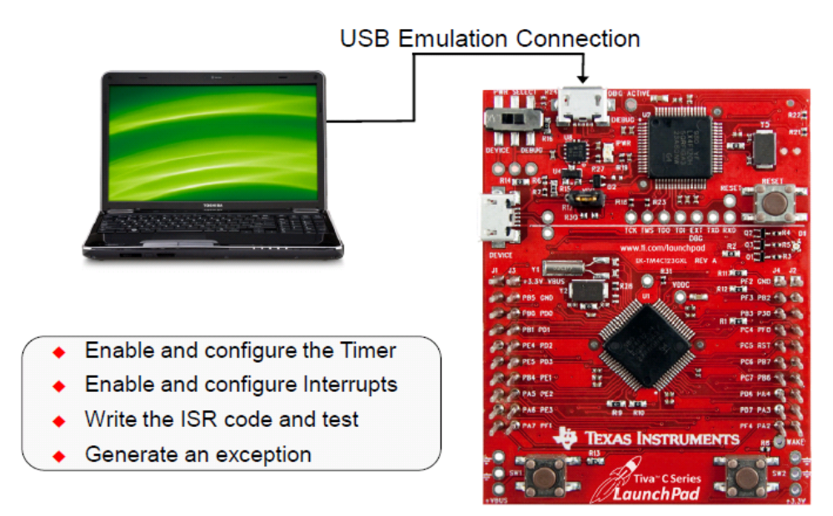
This example accompanies the book "Embedded Systems: Introduction to ARM Cortex M Microcontrollers" ,Open the Profile_4C123 project, and make this option Dialog DLL DCM.DLL Parameter -pCM4 –dLaunchPadDLL，you can use logic analyzer connected to three GPIO pins, and simulate I/O with DCM.DLL and - pCM4 –dLaunchPadDLL.

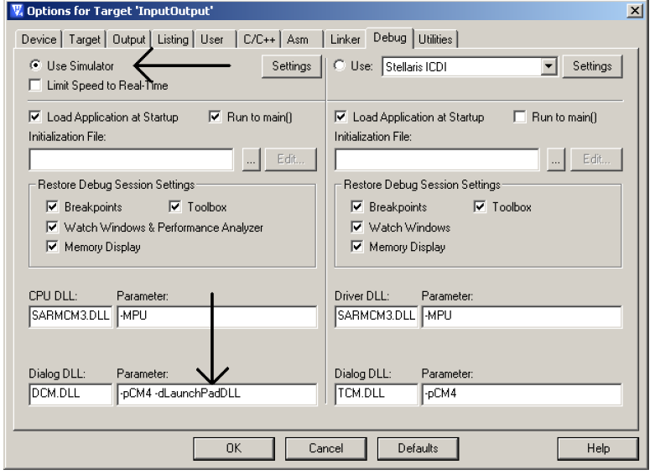

Open project “Profile_4C123” from D:\Keil\EE319KwareSpring2016
Profiling using an Output Port
When more than one thread is active, you could use the previous technique to visualize the thread that is currently running. For each thread, we assign an output pin. The debugging instrument would set the corresponding bit high when the thread starts and clear the bit when the thread stops. We would then connect the output pins to a multiple channel scope or logic analyzer to visualize in real time the thread that is currently running. Program 9.13 shows a simple thread profile of a system with a foreground thread (main program) and two background threads (SysTick and Timer). Three Port A outputs are used to visualize execution PA5 will toggle when the software is running in the foreground PA4 will pulse high then low when executing the SysTick ISR PA3 will pulse high then low when executing the Timer ISR The SysTick and Timer initializations were shown previously in Program 9.7 and 9.8 respectively. The timer is running at priority3 and SysTick is running at priority 2 (higher). The debugging instruments are shown in bold.
Bit-specific addresses are used so the two accesses to Port A do not interact with each other. The results shown in Figure 9.15 demonstrate the two interrupts occurs periodically . Furthermore the results show, most of the time the software is running in the foreground. The time to execute the ISR is short compared to the time between interrupt requests. This represents a good interrupt design. The following labels in Figure 9.15 illustrate these events
A) The main program is running
B) A Timer0 interrupt service has begun
C) A SysTick interrupt service has begun
D) The SysTick ISR is finished
E) The Timer0 ISR is finished
F) The main program resumes
The A-B-C-D-E-F labels illustrate the case when that the SysTick interrupt has suspended the execution of the Timer ISR. The other interrupts on this trace do not overlap.
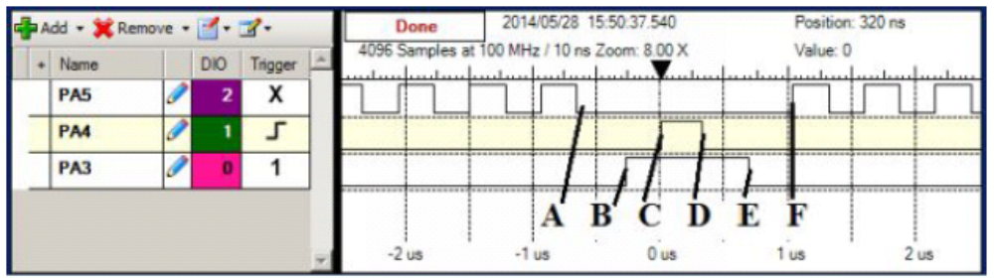
Figure 9.15. Real-time thread profile measured with a logic analyzer. Trigger is set for condition PA3 is high (running Timer0 ISR) and rising edge of PA4 (start of SysTick ISR).
在板子上跑程序：
仿真完成后把相应端口PA3,4,5换成PF1，2,3.重新对端口初始化设置。
先设置每1s Time定时中断并PF2切换亮灭，改变定时初值观察结果。
再对系统定时器中断时间重新设定为10ms,在其中断服务程序中对PF3切换状态.

